



**SDP - Group 18**

**Group Members:**

Alice Wu

David Speers

Deividas Lavrik

Finn Zhan Chen

Mahbub Iftekhar

Mariyana Cholakova

Michal Dauenhauer

# 1 System Overview

RoboTour is a robotic tour guide that assists people in environments such as museums or art galleries. The system comprises of an autonomous robotic guide, a purpose built Android application, and a web server mediating the communication between the two. RoboTour can be controlled by up to two Android devices, and the tour may be followed by many more. The app allows users to interact with RoboTour intuitively in multiple languages.

The RoboTour has been designed for minimal maintenance, once the initial setup has been performed. This guide will outline necessary preparation steps, typical usage examples and a description of nominal behaviour of the robot. A troubleshooting guide is also provided at the end of the document.

## 1.1 System Components and Prerequisites

To follow this guide you’ll need:

* An Android device with *Android 4.1 Jelly bean or higher*, and an Internet connection
* A computer with Bluetooth and an Internet connection
* The built robot with all the necessary files installed on the EV3 (this is provided for you)

## 1.2 Hardware Structure

### 1.2.1 Robot

|  |  |  |  |  |  |  |  |  |  |  |  |  |  |  |  |  |  |  |  |
| --- | --- | --- | --- | --- | --- | --- | --- | --- | --- | --- | --- | --- | --- | --- | --- | --- | --- | --- | --- |
| **Fig. 1:** Labelled view of RoboTour | |  |  | | --- | --- | | **Quantity** | **Item** | | 1 | LEGO Ultrasonic sensor | | 2 | LEGO colour sensors | | 2 | HC-SR04 Ultrasonic sensors | | 1 | Custom Line sensor | | 1 | Motorised Pointer | | 2 | Drive wheels | | 1 | Arduino Sensor hub | | 1 | Lego EV3 brick |   **Table 1:** Robot Components    **Fig. 2:** EV3 brick |

RoboTour can navigate around using two independently powered wheels, which allows it to move forwards, backwards, and turn. The rear free-moving wheels stabilise the robot and support its weight.

Ultrasonic sensors on the front and sides of the robot allow RoboTour to safely avoid obstacles during its operation. The two LEGO colour sensors help RoboTour locate its position in the world by detecting branches and delimiting lines. The custom line sensor is used to navigate along white lines on the floor.

The central element of the robot is the EV3 unit that is the main computing node and also houses the battery pack. The Arduino board serves as a sensor hub in the front of the robot. Table 1 lists the main robot components.

### 1.2.2 Components location and connection

Table 2 details the interconnection between components.

Note that the colour and line sensors are sensitive to the height of the placement. They should be mounted approximately 4 mm from the ground and level to it.

|  |  |  |  |  |  |  |  |  |  |  |  |  |  |  |  |  |  |  |  |  |  |  |  |
| --- | --- | --- | --- | --- | --- | --- | --- | --- | --- | --- | --- | --- | --- | --- | --- | --- | --- | --- | --- | --- | --- | --- | --- |
| |  |  | | --- | --- | | **Element** | **Port** | | Left drive motor | EV3 PORT B | | Right drive motor | EV3 PORT D | | Pointer motor | EV3 PORT C | | Left colour sensor | EV3 PORT 4 | | Right colour sensor | EV3 PORT 1 | | Front ultrasonic sensor | EV2 PORT 2 | | Sensor hub | EV3 USB host port (Fig. 2b) | | Left ultrasonic sensor | Sensor hub sensor port0 (Fig. 2a) | | Right ultrasonic sensor | Sensor hub sensor port1 (Fig. 2a) | | Front line sensor | Sensor hub I2C port (Fig. 2a) |   **Table 2**: Showing which EV3 port connects with each sensor / motor | **Fig. 2a**: Sensor hub ports locations    **Fig. 2b**: EV3 USB host port location  (Lynda,2018) |

## 1.3 Software Structure

There are three main components to RoboTour:

* Android App - Responsible for allowing the user to select paintings they wish to go to and send commands to the robot.
* Server: All android devices communicate to the robot via the server. The server is responsible for mediating and storing commands between all Android devices and the robot. The purpose of having the server is to allow multiple android devices to communicate with the robot.
* Robot: Oversees path planning and navigation around the museum.

This structure can be seen below in Fig. 3.

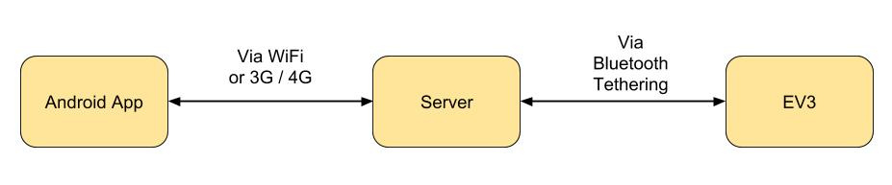

**Fig. 3:** Communications between the elements of RoboTour

# 2 Setup and Preparation

## 2.1 Working Environment

The RoboTour is designed to operate in an environment which you can see in Fig. 4. The black and white lines used for navigation are 25mm in width and must be placed on a gray background. Please note that it is essential that the lines are created using a single layer of tape to ensure reliable tracking.

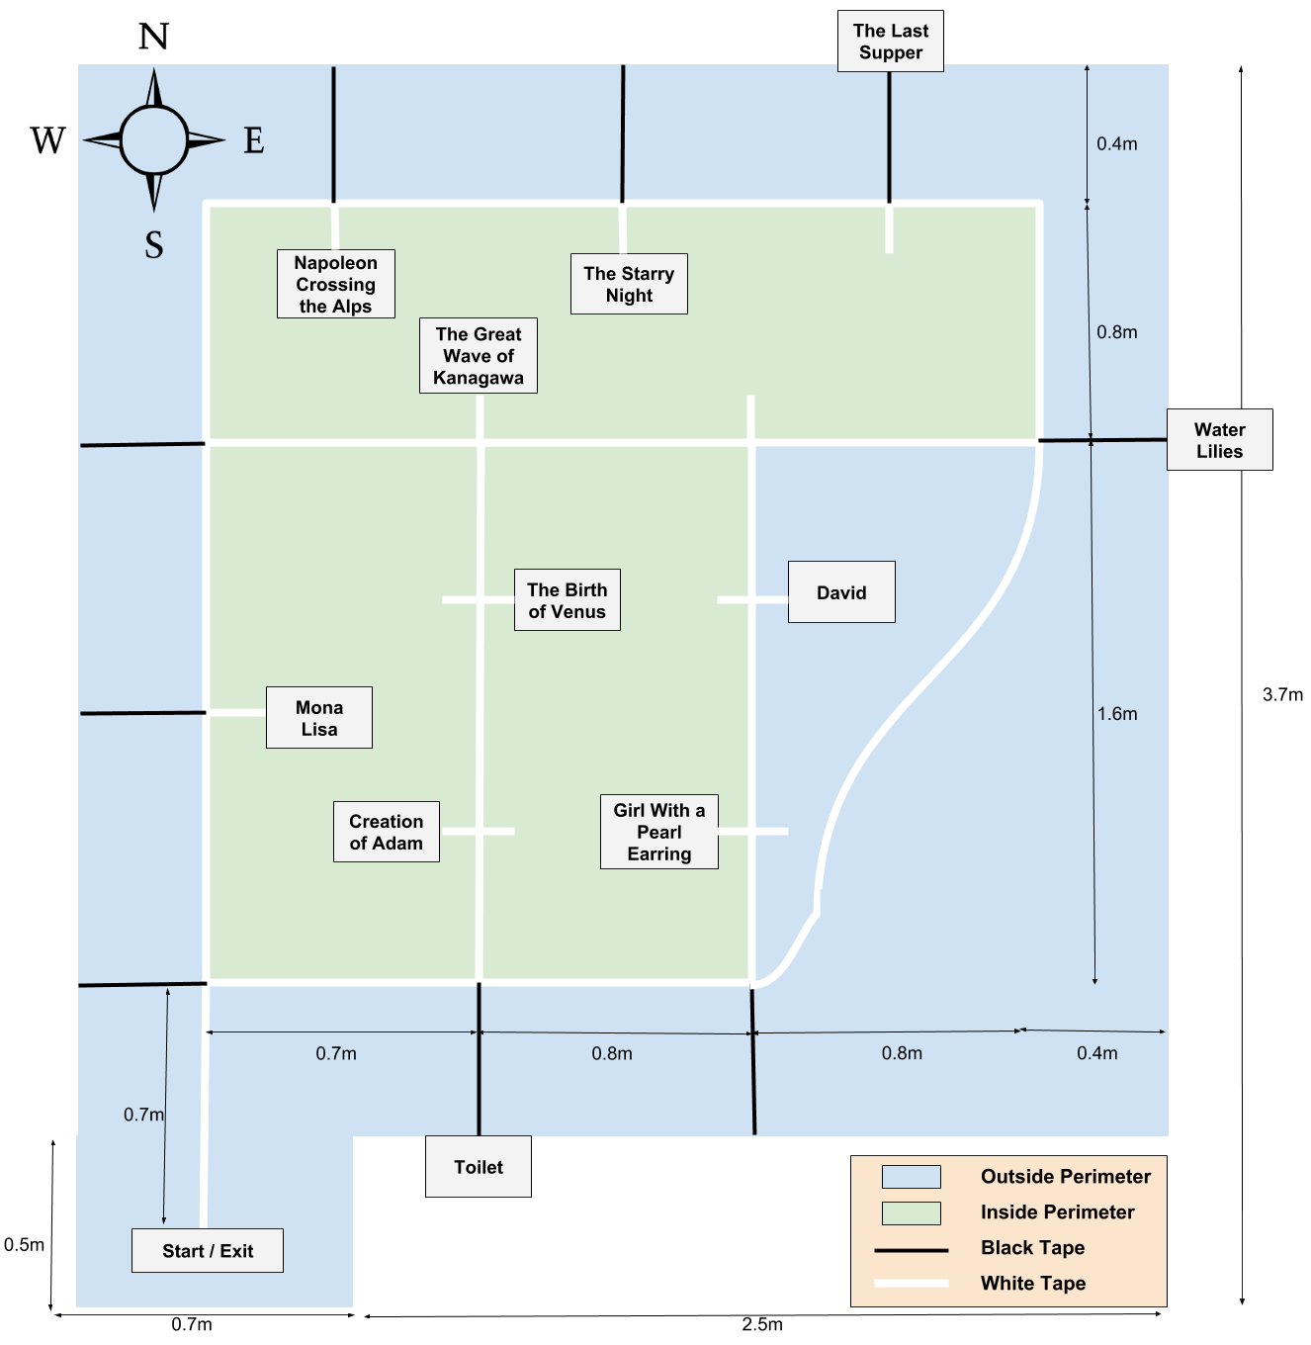

**Fig. 4:** Map of the Museum Environment

## 2.2 Robot setup

### 2.2.1 Turning on the EV3 and basic usage

|  |  |
| --- | --- |
| Fig. 5 shows the navigation buttons present on the EV3.  Turn on the EV3 by long pressing button 4. It takes approximately 40 seconds for the EV3 to start up.  You can use buttons (2, 3, 5, 6) to navigate around the screen, 4 to select and 1 to go back. | **Fig. 5:** EV3 buttons (ev3dev 2018) |

### 2.2.2 Bluetooth tethering

RoboTour requires an Internet connection to operate. It is provided via Bluetooth connection with a host computer. The computer can be also used to update robot’s firmware or for debugging.

Detailed instructions on how to set up Bluetooth Internet tethering are available here:

[http://www.ev3dev.org/docs/tutorials/connecting-to-the-Internet-via-Bluetooth](http://www.ev3dev.org/docs/tutorials/connecting-to-the-internet-via-bluetooth) .

Please follow the guide for your platform.

In the Bluetooth menu in EV3 select the option for the connection to be established manually for easier subsequent uses.

## 2.3 Installing Android Application

To install the app on an Android device, installation from unknown sources must be enabled. This feature is turned off by default on stock Android, and can be turned on by following these steps:

*Device Settings* -> *Advanced Settings* -> *Security* -> *Enable Unknown Sources*

To download the app visit the following link from your phone:

[homepages.inf.ed.ac.uk/s1553593/download.php](http://homepages.inf.ed.ac.uk/s1553593/download.php)

A file called RoboTour.apk will begin downloading automatically.

Once the apk is downloaded, go to the Downloads folder on your phone and click on the apk or select it from the notifications bar. Follow the installation instructions. Once installed the app will be in your App drawer under RoboTour. Tap the app to open it.

# 3 A Typical Tour

If you followed the setup and preparation steps the robot should be on, and connected to the Internet and the app should be open on your Android device.

## 3.1 Initialising the Robot

1. Place the robot at the starting location, facing “North” (Fig. 4). The robot should be placed directly over the white line, away from any coloured markers.
2. Using EV3 navigation buttons, enter File Browser and select main.py to start the main program.
3. The robot will complete self-diagnosis and calibrate the line sensor by rotating left and right. After this procedure, the robot will say “Please select single or multi user mode” to indicate its readiness.
4. To select Single User mode press the left button (3 in Fig. 5).  
   To select Multi User mode press the right button (5 in Fig. 5).
5. Once you hear “Please select the paintings you want to go to”, the robot is ready to start a tour, which can be initiated using the Android application.

## 3.2 Starting the Tour (App)

Once 3.1 is completed click the “Start” button on your Android device.

The next screen (Fig. 6a) will display languages for you to select, if your language is not shown, select the “?”, which does not give any descriptions for the paintings, only the titles in English. The description of the art pieces, audio description and all the settings will be in your selected language if your language is supported.

The application will show the art pieces in the museum (Fig. 6b). Select the ones you would like to visit by tapping on them. You may also choose to search for paintings or ask for recommendations via speech commands by tapping on the microphone or by using the search bar.

The application will recognise commands with the following keywords:

* Art Piece name
* Artist name
* “Best”
* “Popular”
* “Recommend”
* “New”

(In your selected language)

After all selections are made, press “Start Tour” and RoboTour will calculate an optimal route plan. The robot will be inactive while these calculations are performed.

(In Multi User mode the tour will not start until the other user has made their selections and also pressed “Start Tour”.)

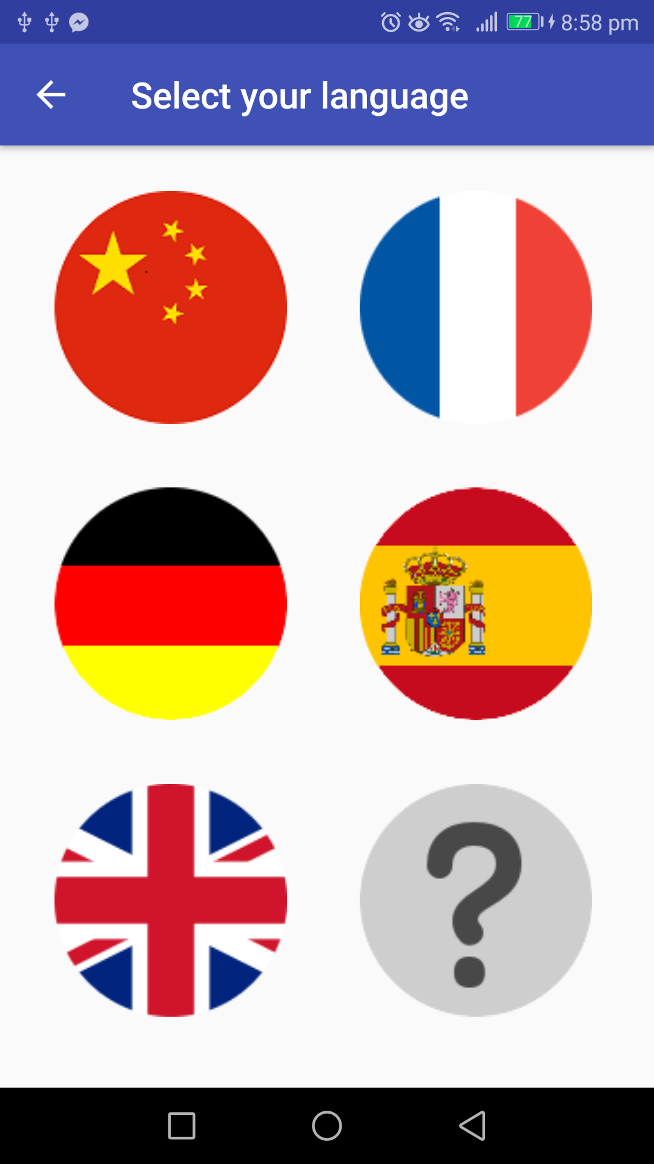 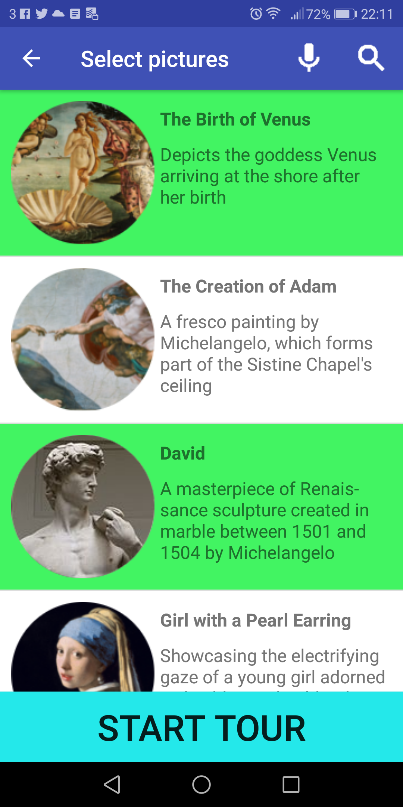 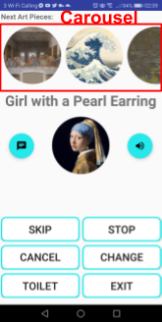 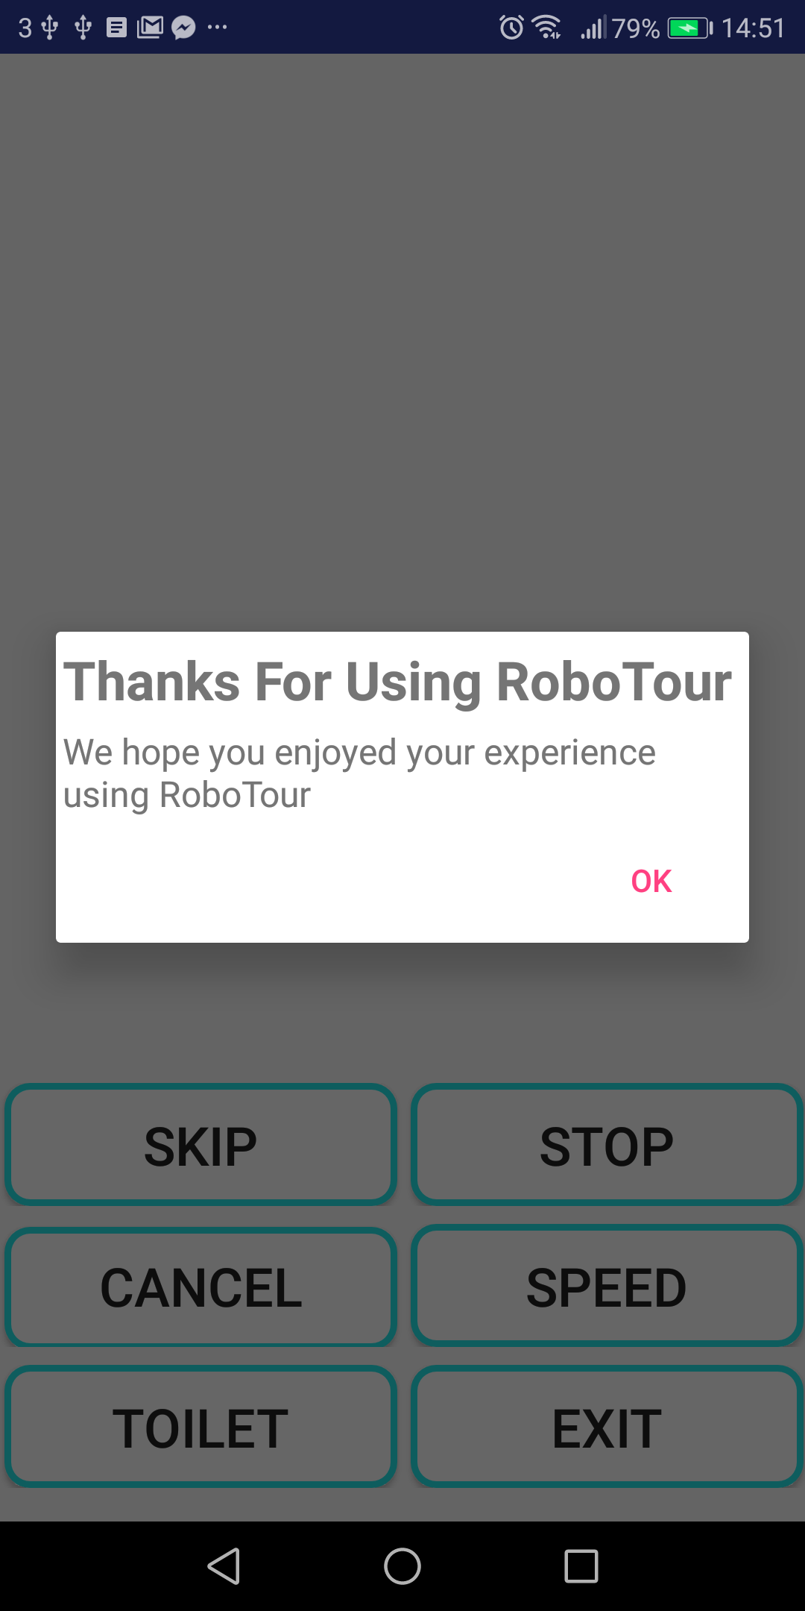

**Fig. 6a**: Language Selection **Fig. 6b**: Painting Selection **Fig. 6c**: Navigation **Fig. 6d**: Tour Ended Alert

## 3.3 Following a Tour

After completing 3.1, the robot will follow the white lines guiding you to all the paintings that were selected on the Android device(s). Once it reaches each painting it will stop, show the painting using the motorised pointer, and the app will use text-to-speech to provide information about the painting. After the app has finished speaking the robot will continue to the next closest painting using Dijkstra’s algorithm (Thomas H. et al., 2001).

## 3.3 Robot Interactions During the Tour

Obstacle avoidance only occurs in the outside perimeter (blue area in Fig. 4). If the robot doesn’t have access to the outside perimeter, it will stop before the obstacle and request the obstacle be removed. Once the obstacle is removed, the robot will continue the tour.

If it’s in the outside perimeter and detects an obstacle, it will enter obstacle avoidance mode:

1. Robot rotates 45 degrees in the direction towards the outward direction of the perimeter (away from the green area in Fig. 4).
2. The robot will follow the shape of the obstacle by maintaining a constant distance from it.
3. The obstacle avoidance is completed once it returns to the white line. (See Fig. 7)

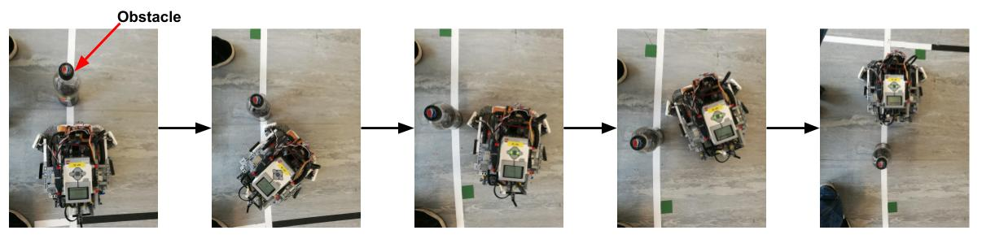

**Fig. 7**: Obstacle avoidance

## 3.4 App Interactions During the Tour

During the tour the app will display the navigation activity (Fig. 6c) . Here you can select any of the buttons to execute the following commands

|  |  |
| --- | --- |
| **Button** | **Action** |
|  | Bring up an alert with the estimated time of arrival, and description of the current painting. |
|  | Make the application read out the description in your selected language. |
|  | Skip the current painting (In Multi User mode an alert will pop up for the other user so that they can accept or cancel the decision). |
|  | Pause the robot until “CONTINUE” is pressed. (This button turns into the “CONTINUE” button once it is pressed). |
|  | Unpause the robot until “STOP” is pressed. (This button turns into the “STOP” button once it is pressed). |
|  | Cancel the tour (robot will return to the starting position and you will be taken to the home screen on the app). |
|  | Navigate to the exit. |
|  | Adjust the speed of the robot. Three modes available; fast, medium, and slow. |
|  | Navigate to the toilet. |
|  | Selecting a picture from the carousel will bring up an alert with the description of that painting, and a button to cancel it. |

## 3.5 Finishing the Tour

Once all the selected paintings have been visited the tour will end and the robot will return to the exit (the starting position). Once it reaches the exit it will turn around and wait for a new tour to begin. The app will display an alert letting you know that the tour has ended (Fig. 6d). Pressing OK will take you back to the home screen.

## 3.6 Turning Off the EV3

|  |  |
| --- | --- |
| Once you’ve finished all tours, you can turn off the EV3. To do this, repeatedly press button 1 until the shutdown menu appears (Fig. 8), then press button 4, and the EV3 will shutdown, which takes approximately 30 seconds. | **Fig. 8:** Exit menu triggered (ev3dev,2018) |

## 3.7 Recharging and Replacing the Battery

The battery lasts approximately 40 minutes from a full charge, and it takes approximately 2 hours to charge from 0 to 100%.

The battery can be recharged with the supplied 10V/700ma barrel plug charger. Connect the charger to the power supply, locate the charging port in the battery underneath the EV3 (accessible from the back of the robot). Green LED will indicate good connection. Red LED will shine until the battery is fully charged.

To replace the battery first detach the EV3 from the body of the robot. There are eight red safety pins holding the EV3 in place. Pull them all one notch away from the EV3 (See Fig. 9). You should now be able to lift the EV3 from the chassis. To release the battery, press on the two latches on the battery pack underneath the EV3.

Insert a new battery pack making sure that the two restrictors feed into their housings. Apply moderate pressure until you hear the latches snap in place. Push the safety pins back into place to secure the EV3 to the chassis.

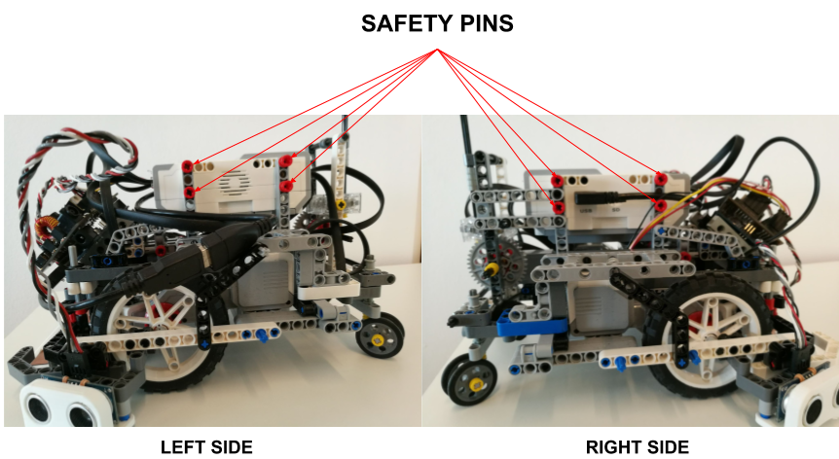

**Fig. 9:** EV3 safety pins locations

# 5 Troubleshooting Guide

|  |  |  |
| --- | --- | --- |
| **ID** | **Problem** | **Solution** |
| 1 | Robot beeps once and does not start moving after starting main.py | Check if Bluetooth tethering between EV3 and Android device is setup properly, and make sure the device is connected to the Internet. |
| 2 | Robot beeps three times and does not start moving after starting main.py | Check if all sensors and motors are connected to appropriate ports (See 1.2.2). All disconnected devices will be shown on the terminal. Restart the program. If the problem persists recharge the battery and try again. |
| 3 | Robot makes a series of short beeps or the front line sensor LED flashes. | Repeatedly press the reset button on the sensor hub and the reset button on the line sensor until the LED starts slowly fading on and off. |
| 4 | Robot fails to avoid an obstacle | Exit the program (See 2.2.1). Make sure that the ultrasonic sensors are connected properly. Keep in mind that the robot can only avoid obstacles if it’s in the outside perimeter. |
| 5 | Robot does not follow the line properly | Make sure that the front line sensor is at approx 4mm from the ground and parallel to it. Restart the program to allow recalibration of the sensor. During the calibration make sure that the entire sensor passes over both the white line and the floor, and over nothing else. |
| 6 | Robot stops at wrong markers | Make sure that the lego colour sensors are at approx 4mm from the ground then restart the program. |
| 7 | Robot is turned on but not responsive to any commands | Force the EV3 to reset by removing the battery, placing it back in again, and turning on the EV3. |

# 

# 6 References

Server URL. [online] Available at: <http://proparoxytone-icing.000webhostapp.com/receiver.php>

Inf.ed.ac.uk. (2018). [online] Available at: <http://www.inf.ed.ac.uk/teaching/courses/sdp/SDP2018/sdp_ev3.pdf> [Accessed 17 Mar. 2018].

Ev3dev.org. (2018a). Using the EV3 Buttons. [online] Available at: <http://www.ev3dev.org/docs/tutorials/using-ev3-buttons/> [Accessed 18 Mar. 2018].

Ev3dev.org. (2018b). Getting Started with ev3dev. [online] Available at: <http://www.ev3dev.org/docs/getting-started/> [Accessed 18 Mar. 2018].

Ev3dev.org. (2018c). Connecting to the Internet via Bluetooth. [online] Available at: <http://www.ev3dev.org/docs/tutorials/connecting-to-the-internet-via-bluetooth/> [Accessed 18 Mar. 2018].

Cormen, Thomas H.; Leiserson, Charles E.; Rivest, Ronald L.; Stein, Clifford (2001). "Section 24.3: Dijkstra's algorithm". Introduction to Algorithms (Second ed.). MIT Press and McGraw–Hill. pp. 595–601. ISBN 0-262-03293-7.

Scontent.net [Accessed 18 Mar. 2018] [online] Available at:

<https://scontent-lhr3-1.xx.fbcdn.net/v/t1.0-9/29497865_10216526568781815_5630111511218225152_n.png?_nc_cat=0&oh=41d28e323133298e16e66cb0d670c3da&oe=5B4673BE>

Lynda.com [Accessed 18 Mar. 2018] [Online] Available at:

<https://www.lynda.com/Mindstorms-tutorials/EV3-brick-brains/455331/482343-4.html>